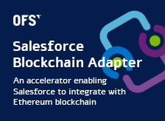

Blockchain Adapter for Salesforce

User Guide with an Example for Security Review

Table of Contents

Installation 3

Preparation for Configuration 4

Preparation in Salesforce (Already done in Test Organization) 4

Preparation in Blockchain (Reviewer may execute these steps to perform full functional tests) 6

Adapter Configuration 11

Adapter Runtime Tests 16

# Installation

Install for Admins Only

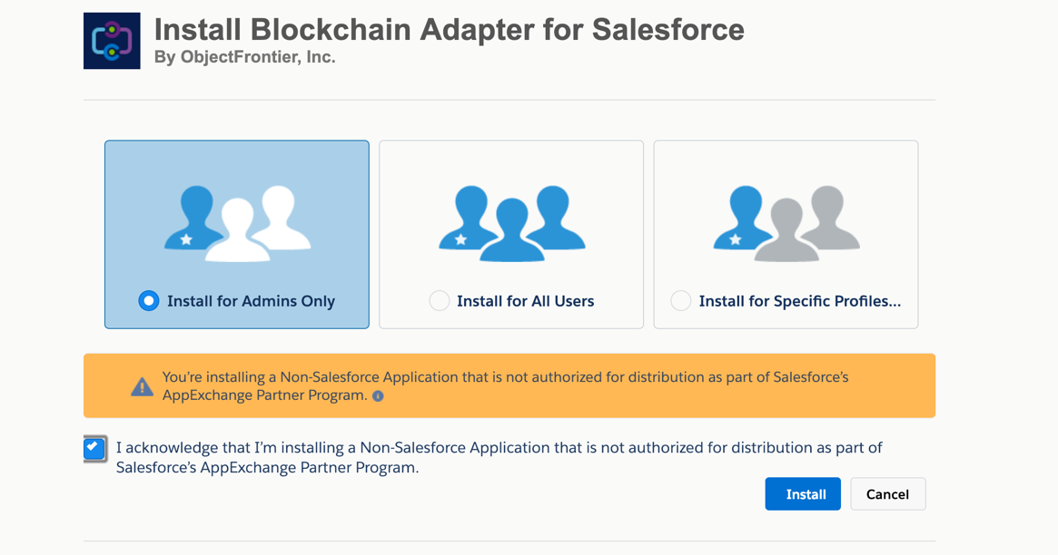

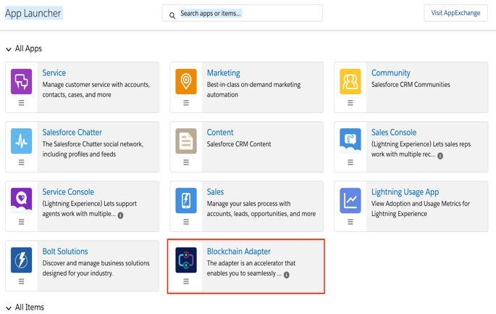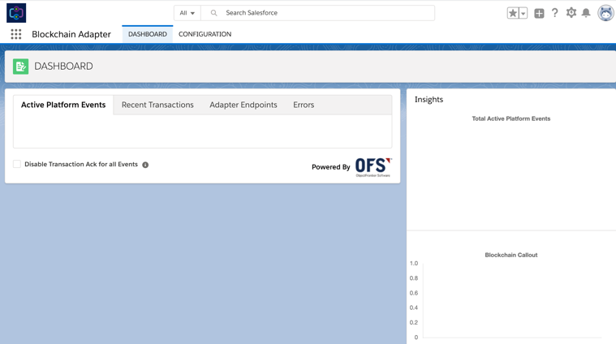

This user guide will walk you through the set-up process using an example. As you progress though the document you will understand the features of the Adapter.

Assume that you have a requirement to develop a Voting app in Salesforce. Let’s say that the app is expected to record every vote and the voter details to blockchain as the vote is cast.

Following are the steps to execute in order to use the adapter to integrate your salesforce application with Blockchain.

# Preparation for Configuration

## Preparation in Salesforce (Already done in Test Organization)

**Voting app**

In this example we create a simple Custom Object

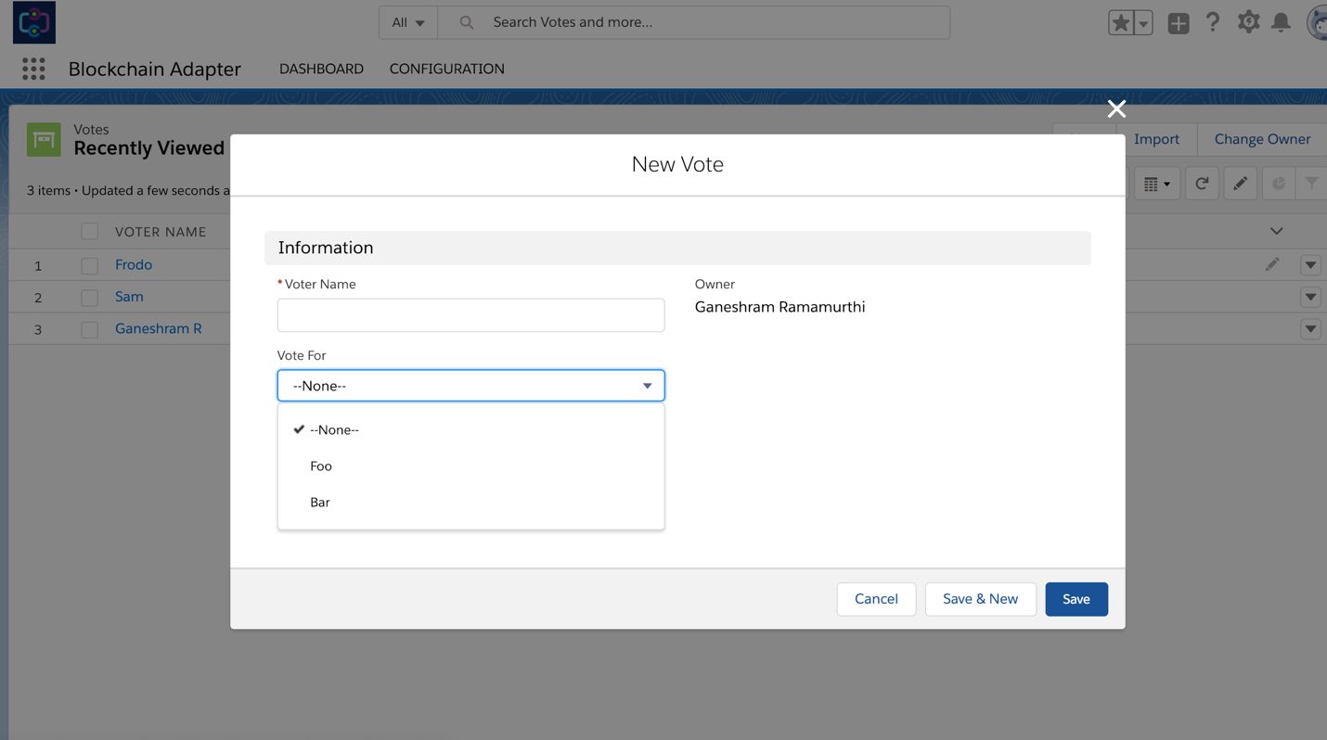

**Platform Events**

This Adapter is entirely platform events driven. To execute our example, we will need a platform event that the adapter should listen to. So, we create a platform event that will trigger when a someone votes for Foo.

Note that the event has 2 custom fields Name and Address. At this point just keep in mind that these are the fields that will be written to the blockchain.

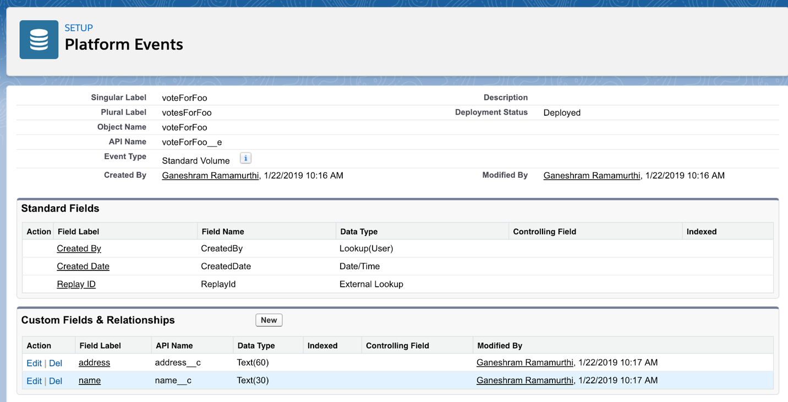

**Process Builder**

Develop and deploy a process that will trigger the above said event when a vote is cast for Foo.

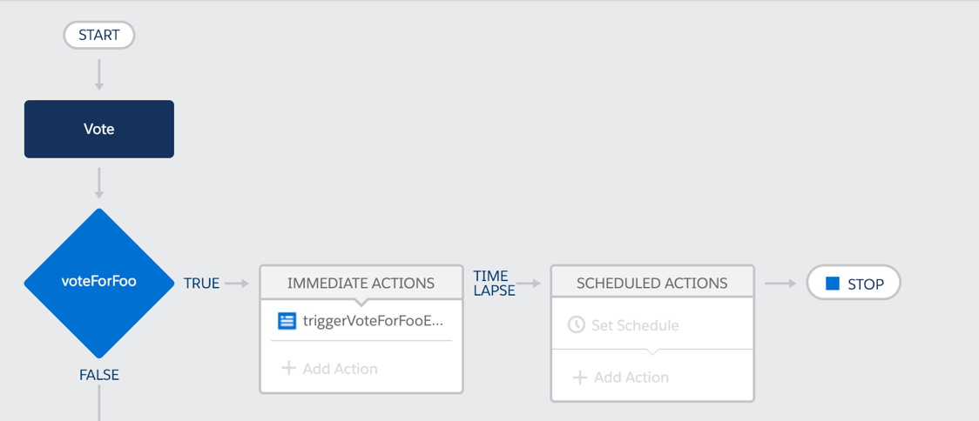

## Preparation in Blockchain (Reviewer may execute these steps to perform full functional tests)

You can use any Ethereum Blockchain that allows RPC calls. For the purpose of security review, you use

<https://ofs-df-blockchain.herokuapp.com/blockchain>

This is an Ethereum blockchain hosted in Heroku for testing purpose.

**Deploy Smart contract to Blockchain**

Deploy the smart contract given below to the blockchain using Remix

1. Launch Remix - <https://remix.ethereum.org/>
2. Set up Web3 Provider

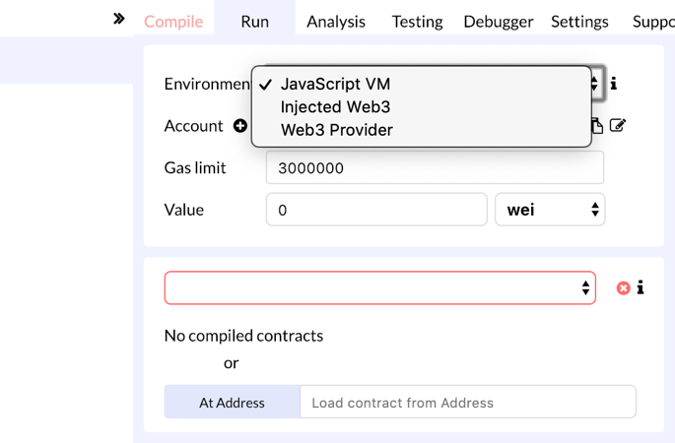

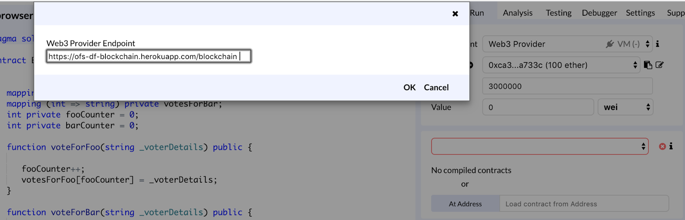

1. Copy and paste the Smart Contract given below – Ballot.sol

<https://github.com/objectfrontiergit/smartContractsForAdapterTest>

1. Pick the compiler version to use

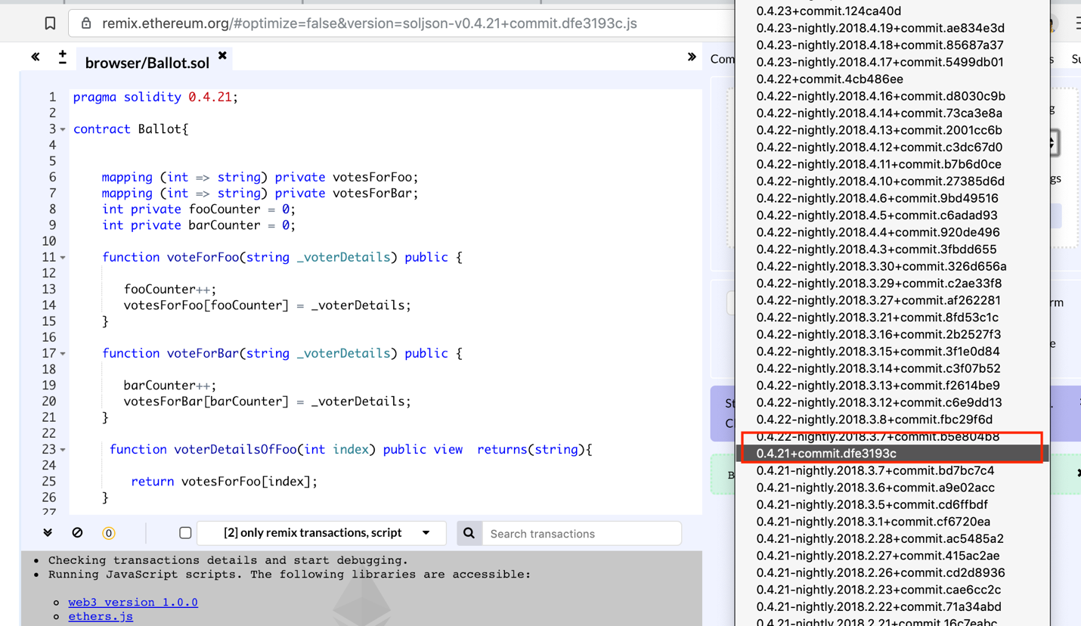

1. Successful Compilation

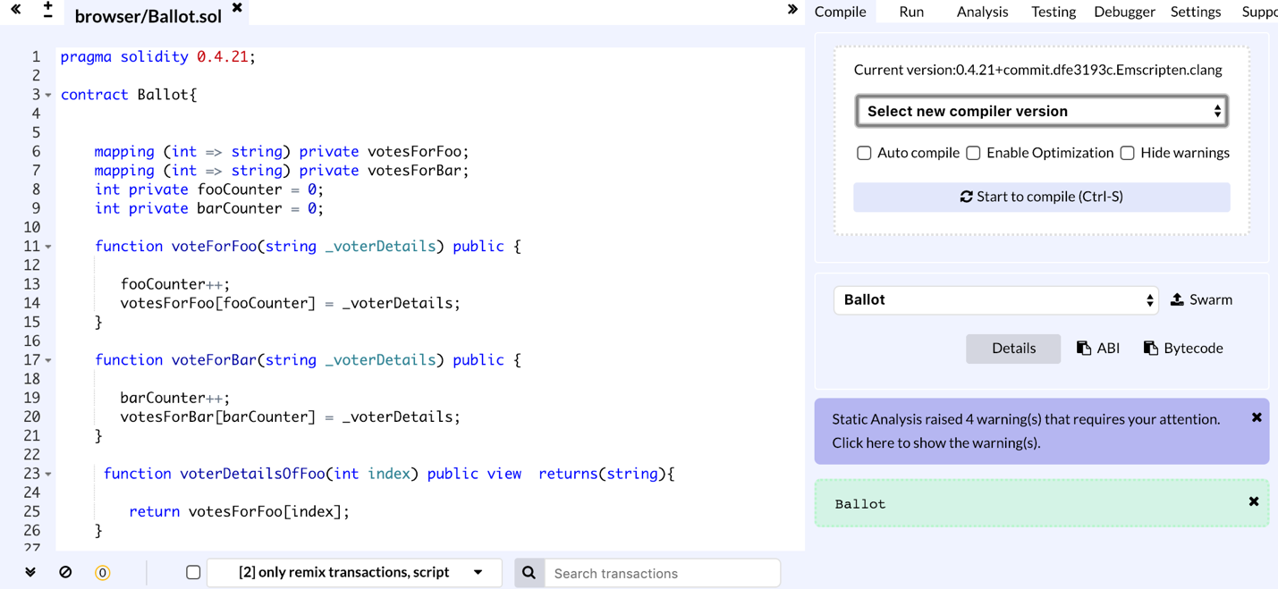

1. Copy ABI and save it in a file

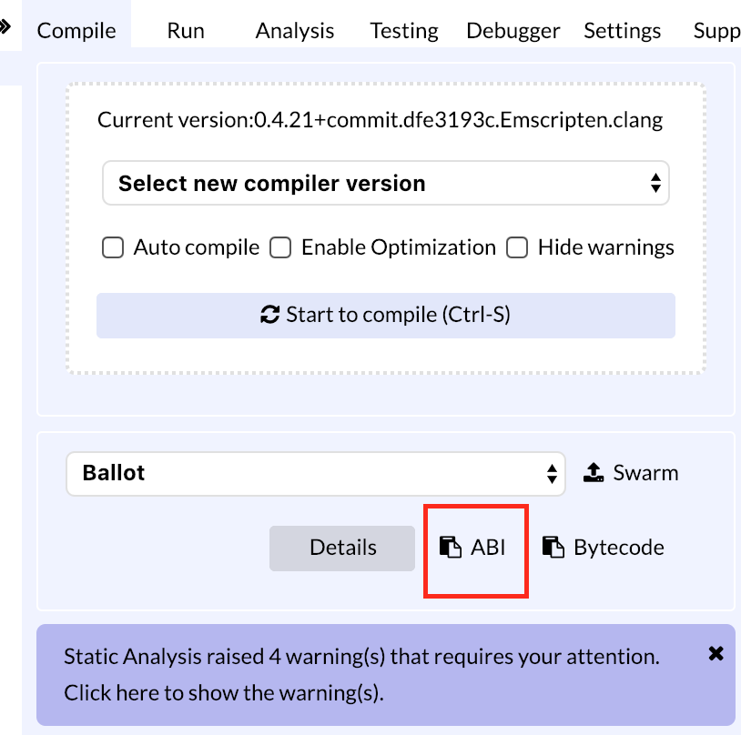

1. Deploy Smart Contract

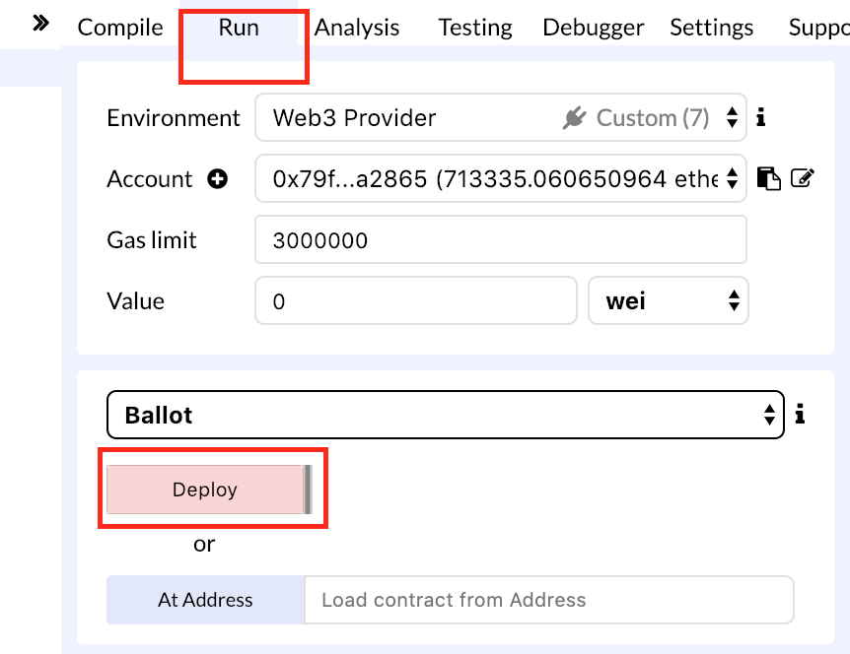

1. Make a note of Contract Id

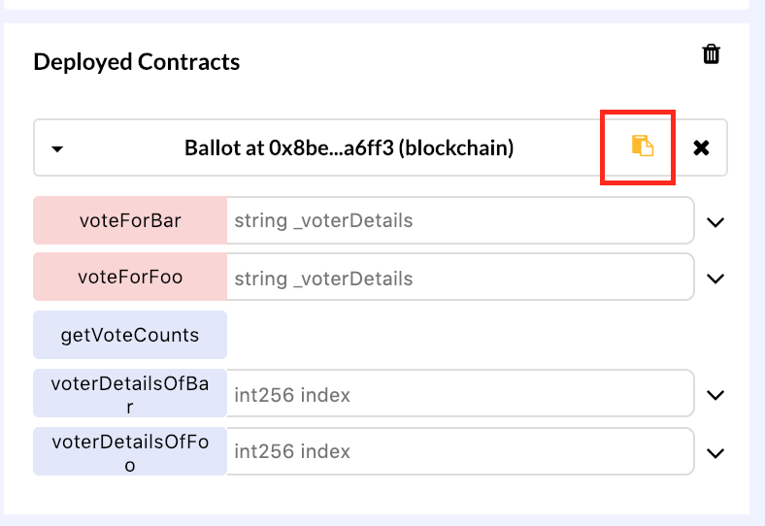

**At this point you are all set to go configure the Adapter.**

### Adapter Configuration

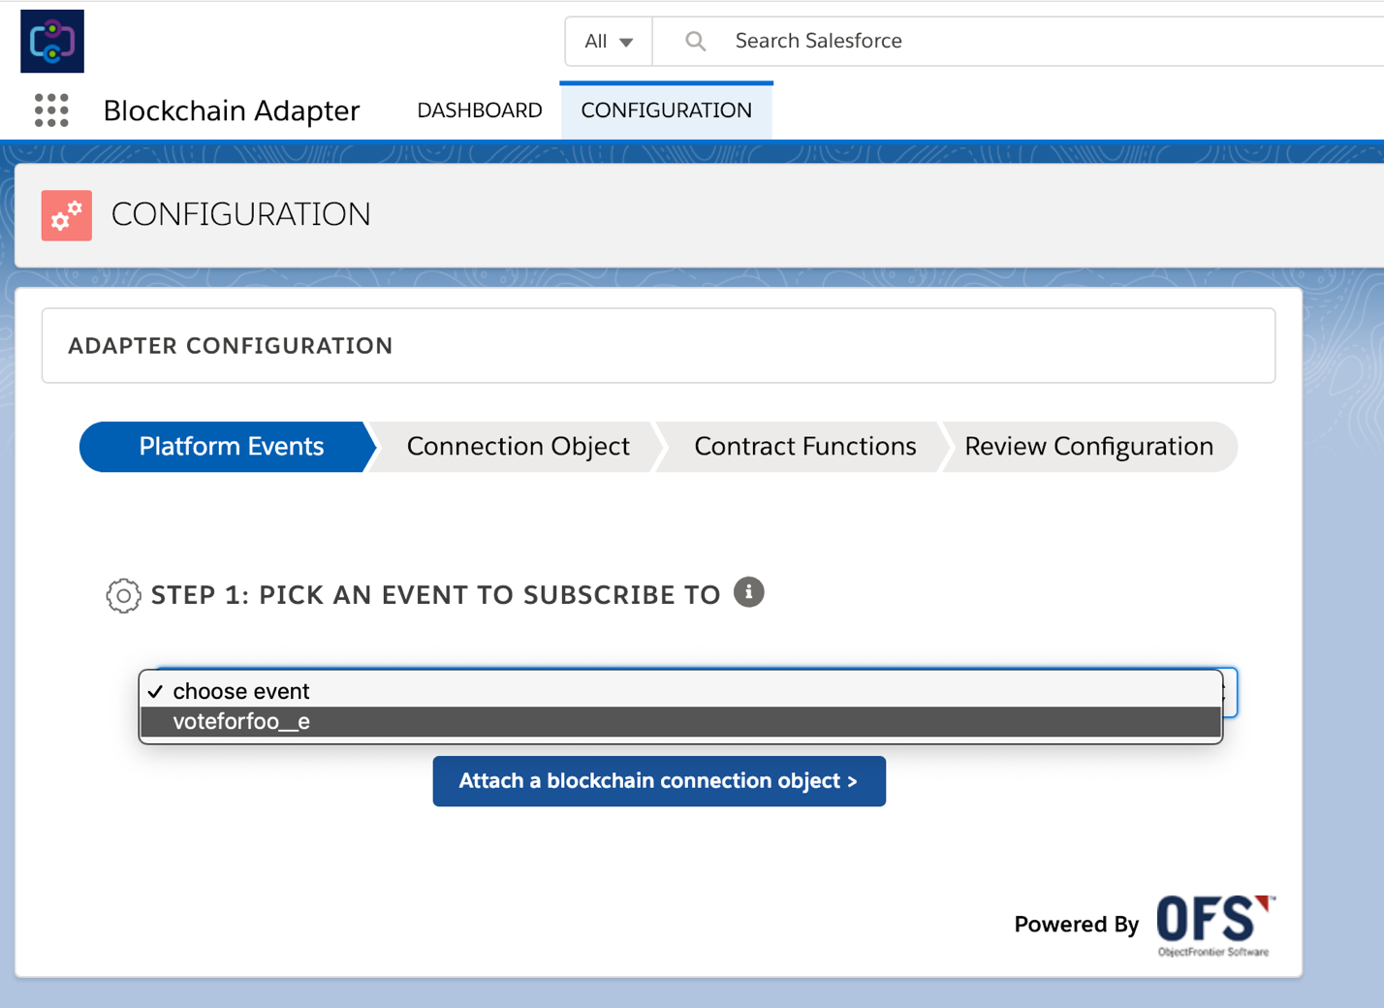

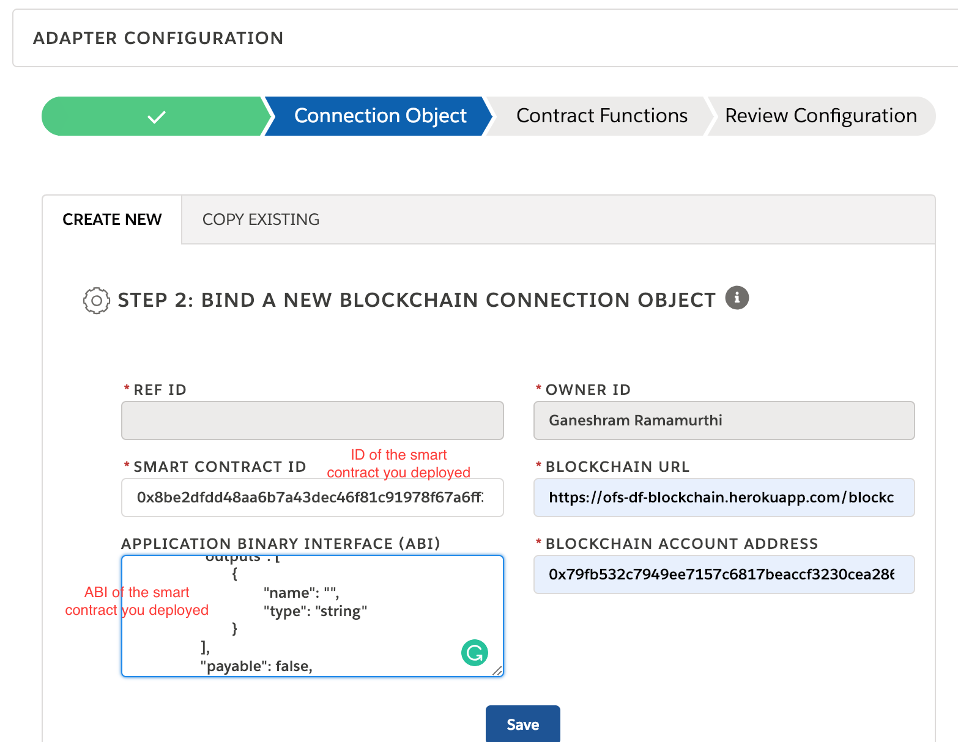

You can use the Blockchain Test Account Address: 0x79fb532c7949ee7157c6817beaccf3230cea2865

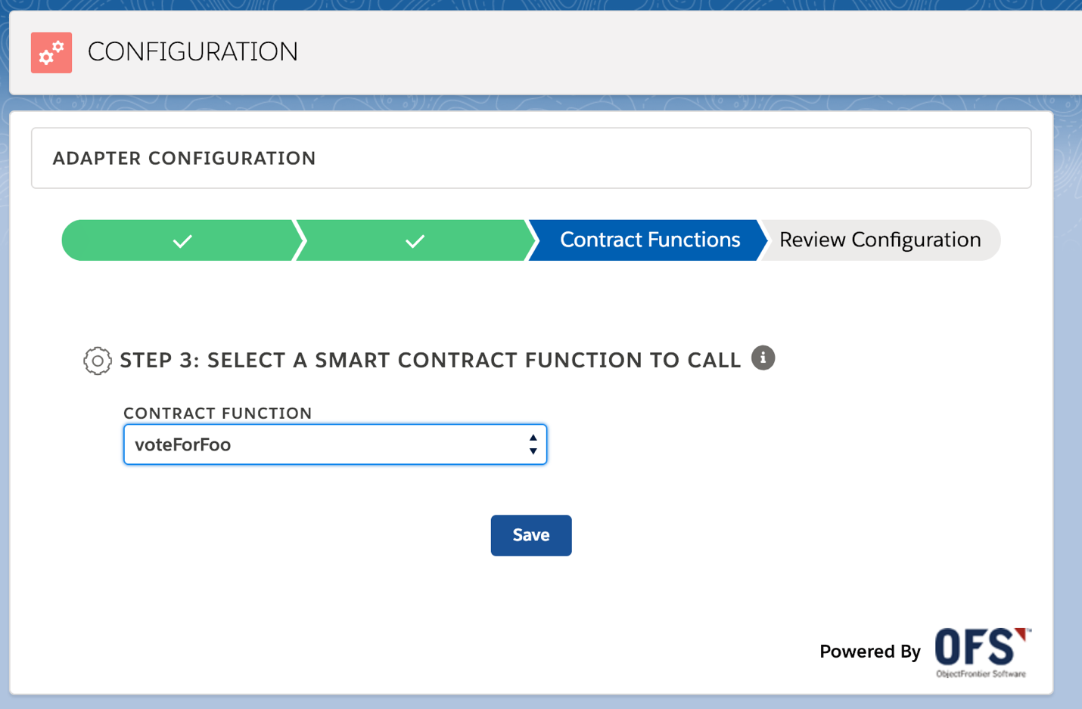

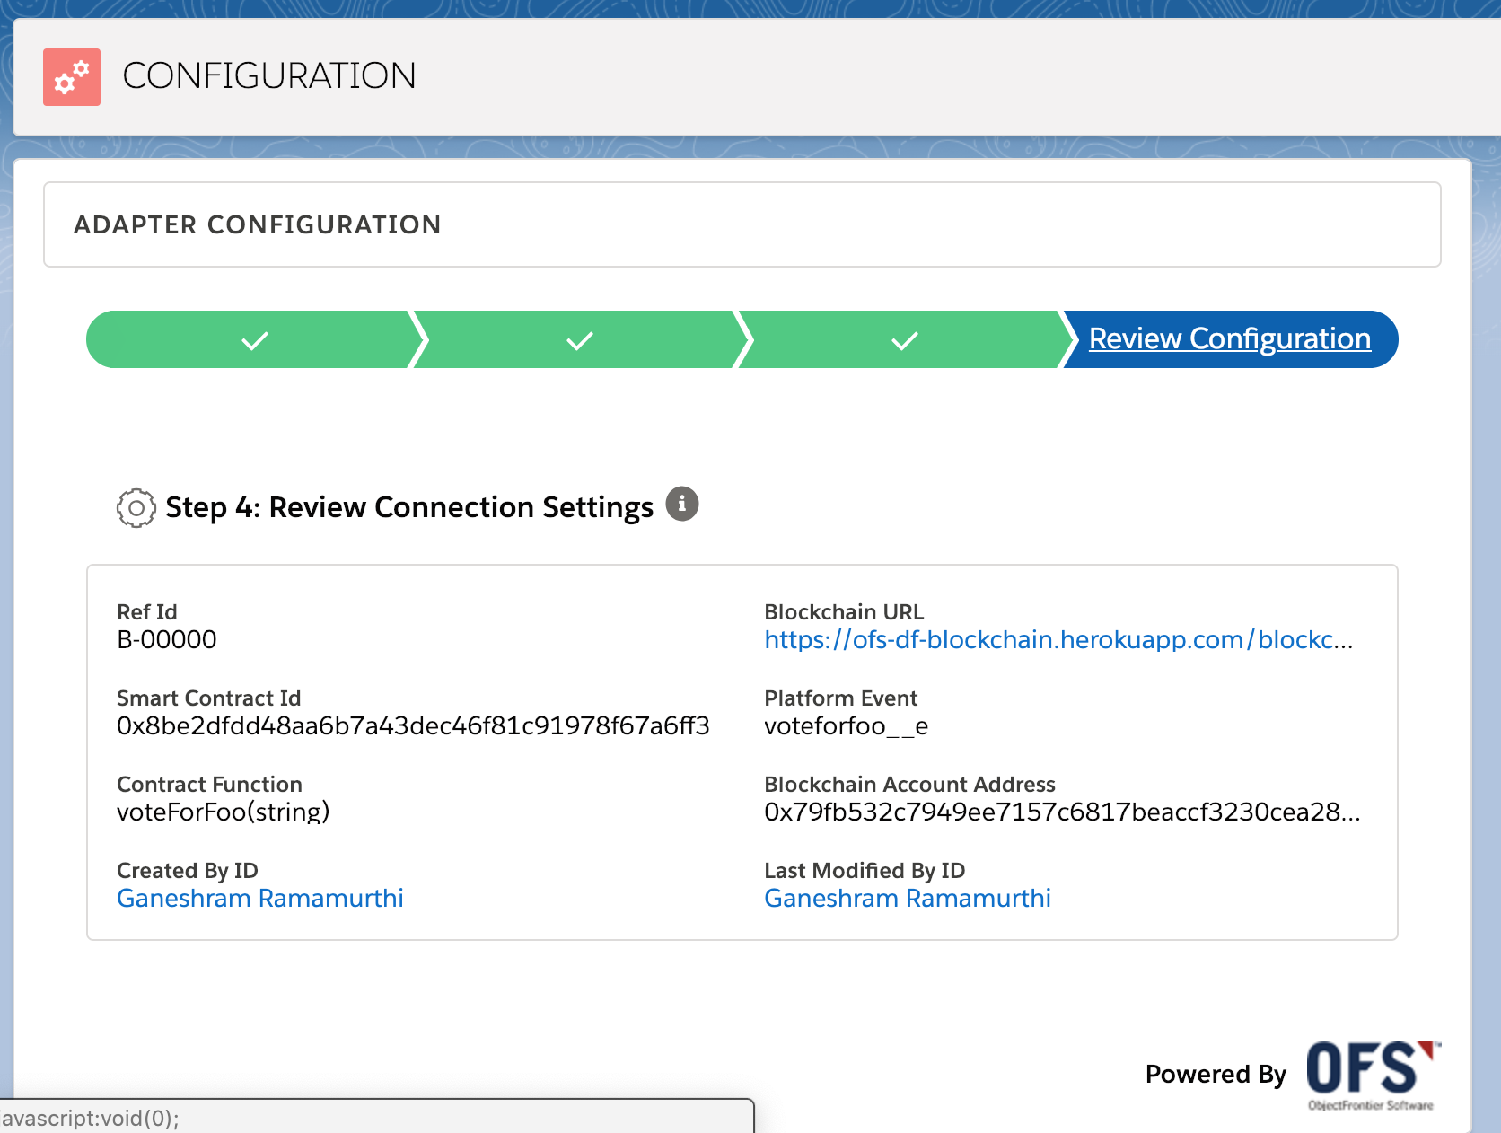

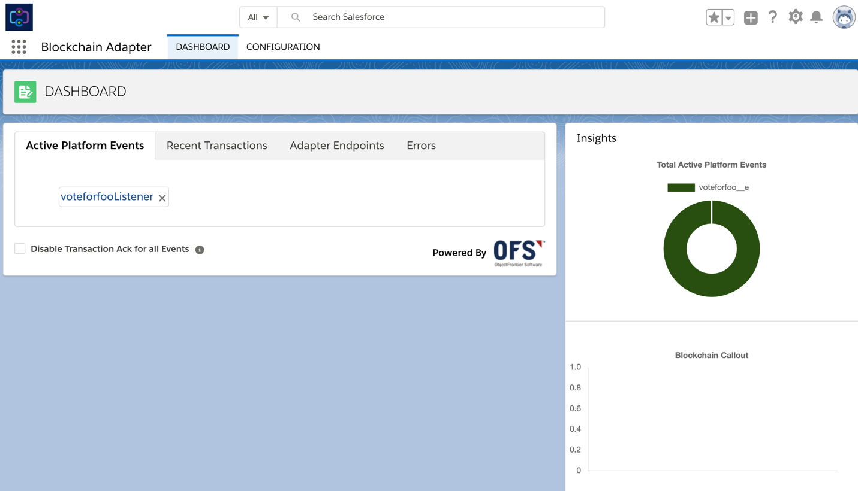

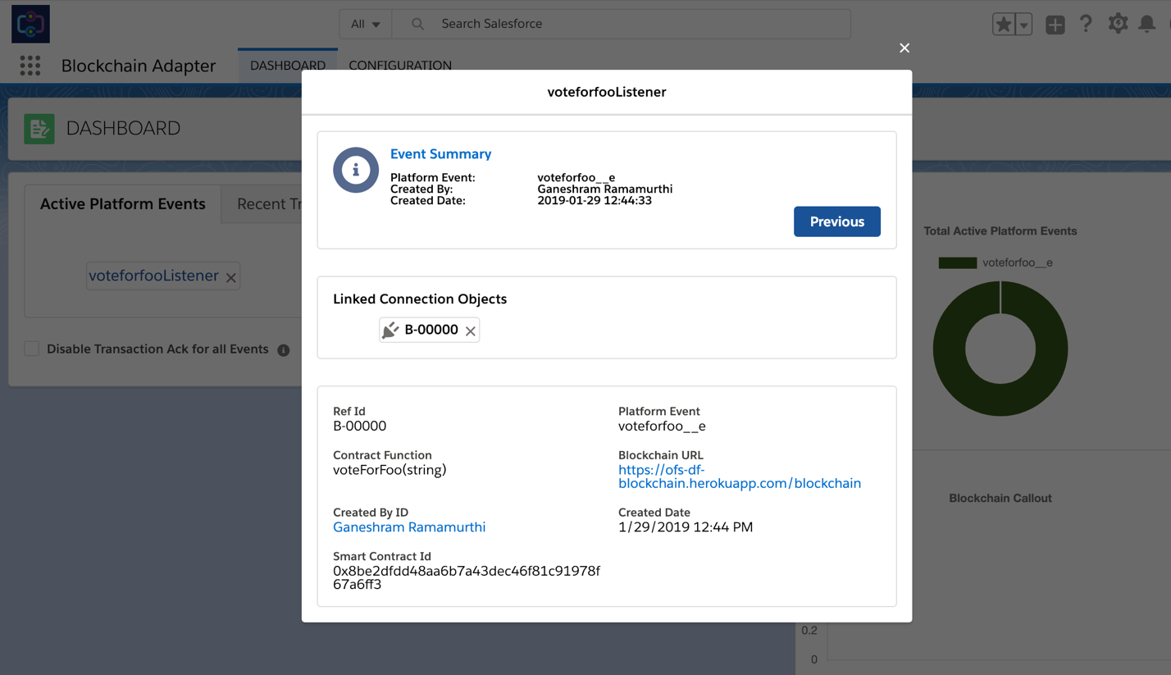

### Adapter Runtime Tests

1. **Save a new Vote**

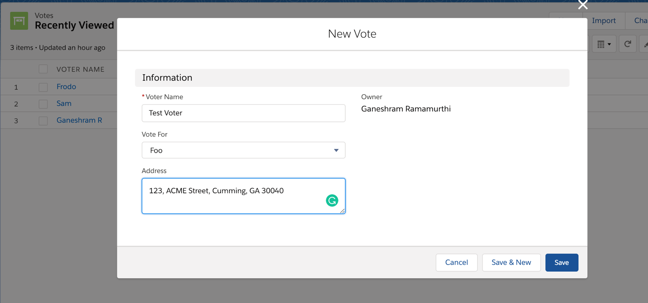

1. **View Dashboard**

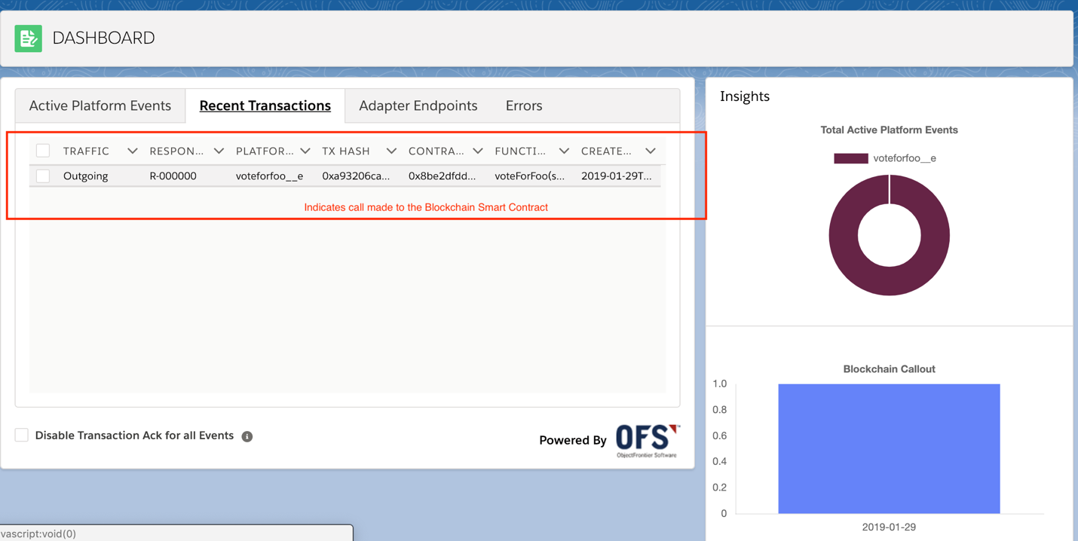

1. **Test in Remix**

